|  |
| --- |
| Day 3 – Task ( Bootstrap ) |

**Task 1**

Create a responsive html page with bootstrap for below layout.

Before start this page you should know all the components in bootstrap from **http://getbootstrap.com/**

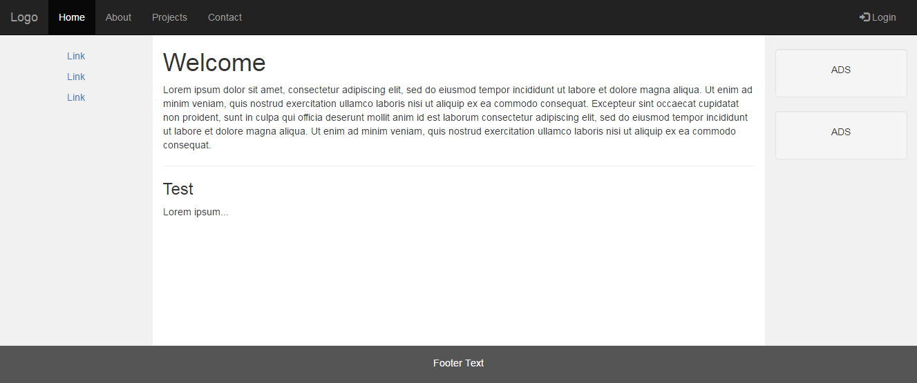

**Task 2**

Create a responsive html page with bootstrap for below layout.

